

Add Feedback

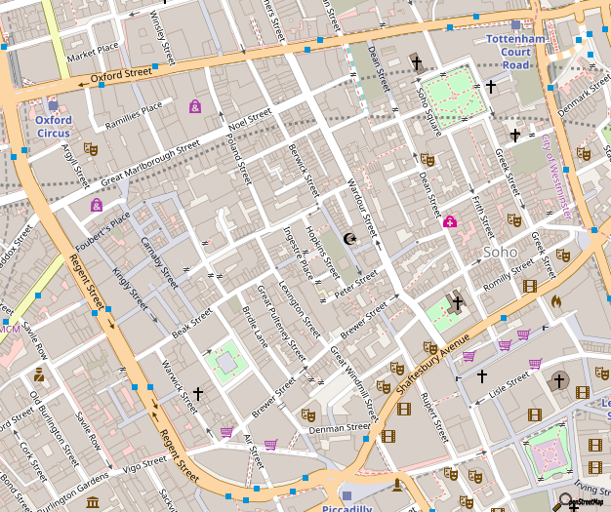

[This Photo](http://en.wikipedia.org/wiki/File:Soho_-_map_1.png) by Unknown Author is licensed under [CC BY-SA](https://creativecommons.org/licenses/by-sa/3.0/)

Mole

Bruise

5

10



Title

Comments:

Add photos



Touch a body part



Edit

Add



Touch a body part

Mole

Bruise

5

10

Touch a body part



Delete

Comments:

Add Geo Location

Add reminder

Save



Set Reminder:

Weekly

Bi-weekly

Monthly

Start Date:

End Date:

Set Time:

CMPUT 301 Project Initial Startup STORYBOARD STATE – **(1)**

Log In

Sign up



**1.1**

**See *2.A or 2.B HOME* storyboarding for either *Patient* or *Care Provider***

Storyboarding Description and Navigation:

* 1. **Initial Startup:**
* This is the first page that a use will initially see when that app is first installed on the phone
* If the user already has a profile (whether is be *Patient* or *Care Giver*) they can filled in the required log in criteria (“Username” and “Password”), then tap “Log In”.
  + If User is *Care Giver* **see *(2.A) HOME – Care Provider***
  + If User is *Patient* **see *(2.B) HOME - Patient***
* If the user doesn’t have an account, they can sign up for one by tapping “Sign up”. **See *1.2* or *1.3* for Sign Up Screen**
  1. **User Sign Up Screen:**
* This page displays the required fields to fill out in order to create an account
* Once all of the required fields are filled out, the user can tap “Save” to officially sign up for the application
* **THINGS OF NOTE:** Is this required for signing up the *Care Provider* as well?? Will there need to be a separate button
* Once the user signs up it will send them back to **1.1 Initial Startup** and ask the user to log in again.
* **Possible wow factor:** Should we add a *Forgot Password?* Button for the user??

Male

Female

Birthday:

Username:

Password:

Save

Phone:

**1.2**

Username:

Password:

CMPUT 301 Project

HOME – Care provider - **(2).A**

Photos

List

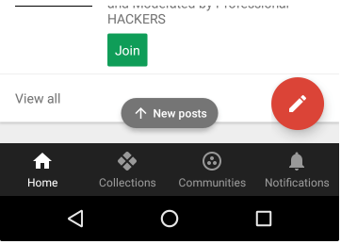

CMPUT 301 Project

HOME – Patient - **(2).B**

CMPUT 301 Project

SETTINGS – Care provider - **(3).A**

CMPUT 301 Project

SETTINGS – Patient - **(3).B**

CMPUT 301 Project

List/Maps/Gallery – Care Provider - **(4).A**

CMPUT 301 Project

Main Application Photos – Patient - **(4).B**